Tata Motors Ordering System
TMO System Design

Version <1.8>

Revision History
Date | Version | Description | Author
4/22/13 | 1.1 | Worked on Section 1 | Ahmed Mansour
4/24/13 | 1.2 | Worked on Section 3 | Luis Goicochea
4/24/13 | 1.3 | Worked on Section 2 | Cristhiam Anhuaman
4/25/13 | 1.4 | Worked on Section 5 | Ahmed Mansour  Miguel Horta
4/25/13 | 1.5 | Worked on Sections 4.1 – 4.7 | Nikolai Ratzkovich
4/25/13 | 1.6 | Worked on Sections 4.8 – 4.15 | Luis Goicochea
4/25/13 | 1.7 | Update Table of Contents | Miguel Horta  Nikolai Ratzkovich  Cristhiam Anhuaman
5/2/13 | 1.8 | Update section 5.1 | Luis Goicochea

Table of Contents
1. Introduction 1
2. System Design Overview 1
3. Tata Motors Ordering System Class 1
4. Class Descriptions 4
4.1 Home Page 4
4.1.1 Attributes 4
4.1.2 Description and Operation 4
4.2 Log In/Sign Up Link 4
4.2.1 Attributes 4
4.2.2 Description and Operation 4
4.3 Sign Up 4
4.3.1 Attributes 4
4.3.2 Description and Operation 4
4.4 Email 4
4.4.1 Attributes 4
4.4.2 Description and Operation 4
4.5 Log In 5
4.5.1 Attributes 5
4.5.2 Description and Operation 5
4.6 User 5
4.6.1 Attributes 5
4.6.2 Description and Operation 5
4.7 Welcome 5
4.7.1 Attributes 5
4.7.2 Description and Operation 5
4.8 Username 5
4.8.1 Attributes 5
4.8.2 Description and Operation 5
4.9 Password 5
4.9.1 Attributes 5
4.9.2 Description and Operation 5
4.10 Admin Control 6
4.10.1 Attributes 6
4.10.2 Description and Operation 6
4.11 Car Model 6
4.11.1 Attributes 6
4.11.2 Description and Operation 6
4.12 Customization 6
4.12.1 Attributes 6
4.12.2 Description and Operation 6
4.13 Dealer 6
4.13.1 Attributes 6
4.13.2 Description and Operation 6
4.14 Payment 6
4.14.1 Attributes 6
4.14.2 Description and Operation 6
4.15 Feedback 7
4.15.1 Attributes 7
4.15.2 Description and Operation 7
5. User Interface Design 7

Design

Introduction
The purpose of the Tata Motors Ordering System is to assist with the purchase of a Tata Motors vehicle.
The Ordering System shall make it as easy and simple as possible for a customer to be able to order a vehicle from the Tata Motors dealership of their choosing. The selection of a vehicle should be as simple as just clicking from the choices that are available. Once a user has chosen a vehicle, the color and customization options should also allow for easy access and choosing. First time users will be able to sign up with ease in just a couple minutes to the Ordering System. Returning users that have purchased a Tata Motors product will be able to look at their account and make payments with ease.

System Design Overview
This document will provide the TMO System Design. First of all, it will show the attributes and methods that each class will have. Next, The relationship between classes will be shown in the design for a clear understanding of the system. The major classes are the Homepage, Login/signup link, Sign up, Email address, Login, User, Welcome, Username, Password, Admin control, customization, car model, dealer, payment and feedback. Furthermore, the classes will be described in the following sections in detailed.

Tata Motors Ordering System Class
In following diagram, it includes all of the classes in this system, and also description of it. The attributes, operations, relations, and comparison within classes are listed in following diagram.
Look at next page for diagram.

Homepage
PIC
CAR
INFO
methods():
getPage()
setPage()
displayPage()
Login/Signup Link
LINK
LIN
SUP
methods():
getLink()
setLink()
chooseLogIn()
chooseSignUp()
systemBegin()
Sign Up
TField
INFO
methods():
getSignUp()
setSignUp()
getInformation()
accessSystem()
Email Address
Email
Verify
methods():
getEmail()
setEmail()
verify()
validateEmail()
Admin Control
Admin
methods():
getAdmin()
setAdmin()

Username
Names
Accept
TField
Avail
methods():
getUsername()
setUsername()
checkAvailable()
tryAgain()
Car Model
Cars
CMIZE
methods():
getModel()
setModel()
chooseCar()
customize()
Log In
UName
PWord
methods():
getLogIn()
setLogIn()
inputUsername()
inputPassword()
User
Customer
Admin
Dealer
methods():
getUserPage()
setUserPage()
logIn()
verifyUser()
Welcome
new customer
user page
methods():
getWelcome()
setWelcome()
newUse()

Payment
Lease
finance
methods():
getPayment()
setPayment()
choosePayment()
monthlyBill()
inputCreditCard()
inputCheckingAccount()
Password
Strong
Weak
Length
methods():
getPassword()
setPassword()
checkStrength()
checkLength()
Dealer
INFO
ZCode
methods():
getDealer()
setDealer()
contactDealer()
getInformation()
Feedback
Car
Dealer
System
getFeedback()
setFeedback()
modelFeedback()
dealerFeedback()
systemFeedback()
Customization
Models
ACC
Color
methods():
getCustomize()
setCustomize()
chooseModel()
chooseAccessories()
chooseColor()

Class | HomePage | Login/Signup Link | Sign Up | Email Address | Feedback
Attribute | PIC  CAR  INFO | LINK  LIN  SUP | TField  INFO | Email  Verify | Car  Dealer
Operation | GetPage  SetPage  DisplayPage | getLink  setLink  chooseLogIn  chooseSignUp  systemBegin | getSignUp  setSignUp  getInformation  accessSystem | getEmail  setEmail  verify  validateEmail | getFeedback  setFeedback  modelFeedback  dealerFeedback

Class | Log In | Welcome | User | Username | Password
Attribute | UName  PWord | NewUser | Customer  Admin  Dealer | Name  Accept  TField  Avail | Strong  Weak  Length
Operation | getLogIn  setLogIn  inputUsername  inputPassword | getWelcome  setWelcome  newUse | getUserPage  setUserPage  logIn  verifyUser | getUsername  setUsername  checkAvailable  tryAgain | getPassword  setPassword  checkStrength  checkLength

Class | Admin Control | Car Model | Customization | Dealer | Payment
Attribute | Admin | Cars  CMIZE | Models  ACC  Color | Information  Zip code | Lease  Finance
Operation | getAdmin  setAdmin | getModel  setModel  chooseCar  customize | getCustomize  setCustomize  chooseModels  chooseAccessories  chooseColor | getDealer  setDealer  contactDealer  getInformation | getPayment  setPayment  choosePayment  monthlyBill  inputCreditCard  inputCheckingAccount

Figure 1. TMO System Class

Class Descriptions
The class diagram describes how classes relate to each other

Home Page Class

Attributes
The Home Page Class has the following attributes: PIC (pictures of cars), CAR (the vehicles themselves), and INFO (information on Tata Motors).

Description and Operations
From this class the user can navigate where they would like to go, including the option of being able to click on the link to go to the Tata Motors Ordering system.

Log In/Sign Up Link Class

Attributes
The Log In/Sign Up Link Class has the following attributes: LINK (the link itself), LIN (log in), and SUP (sign up).

Descriptions and Operations
The user can click on this link when they want to get into the Tata Motors Ordering system once they are ready to purchase a product. They will have the option of either signing up if they are a new user or logging in if they are a returning user. Once they are logged in then they can begin the process of using the system.

Sign Up Class

Attributes
The Sign Up Class has the following attributes: TField (text field where user can input their information) and INFO (the information itself that the user inputs).

Descriptions and Operations
A new user will be able to sign up into the system by inputting their information into the text fields. Once they are signed up they will be able to access the system.

Email Address Class

Attributes
The Email Address Class has the following attributes: Email (the user’s email address) and Verify (verification of the email).

Descriptions and Operations
The user will have to input their email address and the system will verify if it is a valid email.

Log In Class

Attributes
The Log In Class has the following attributes: UName (username) and PWord (password).

Descriptions and Operations
A returning user will be instructed to input their username and password in order to gain access into the ordering system.

User Class

Attributes
The User Class has the following attributes: Customer (a customer wanting to purchase a Tata Motors product), Admin (an administrator who wants to log in to the system), and Dealer (a Tata Motors dealer who wants to access the system).

Descriptions and Operations
The user will log in to the system and the system will verify whether they are a customer, administrator, or Tata Motors dealer.

Welcome Class

Attributes
The Welcome Class has the following attributes: NewUser (new user gets welcomed).

Descriptions and Operations
A new user signing up for the first time will see a welcome page.

Username Class

Attributes
The Username Class has the following attributes: Name (the user has to have a name), Accept (the system has to accept the username), TField (the username has to be inputted into a text field), and Avail (the username has to be available).

Descriptions and Operations
A username has to be inputted by the user when logging in to the system. If they are a new user, the username they choose has to be available.

Password Class

Attributes
The Password Class has the following attributes: Strong (strong password), Weak (weak password), and Length (length of the password).

Descriptions and Operations
A password has to be inputted by the user when logging in to the system. If they are a new user, the password has to be strong enough that no one else will guess it. It must also be of proper length.

Admin Control Class

Attributes
The Admin Control Class has the following attribute: Admin (administrator).

Descriptions and Operations
An admin that uses that system will have control of it.

Car Model Class

Attributes
The Car Model Class has the following attributes: Cars (the Tata Motors vehicles) and CMIZE (customization of car).

Descriptions and Operations
The user will be able to choose the car model they want and how they want to customize it if they choose.

Customization Class

Attributes
The Customization Class has the following attributes: Models (car model), ACC (accessories), and Color.

Descriptions and Operations
The user will be able to choose which model car they want, they color they want, and how to customize their car.

Dealer Class

Attributes
The Dealer Class has the following attributes: INFO (information of the dealer), and ZCode (zip code of dealer).

Descriptions and Operations
Once the user has chosen the Tata Motors they would like to purchase, they choose which dealer they would like to pick up their product from. They do so by inputting a zip code of their choosing to find the closest dealer. Once they have chosen a dealer they will also be presented with that specific dealer’s information making it easier to contact them.

Payment Class

Attributes
The Payment Class has the following attributes: Lease and Finance.

Descriptions and Operations
Once the user has chosen the dealer they would like to pick up their purchase from they will be given to choice of whether they would like to finance or lease their vehicle. Depending on their information they will be given a monthly bill and they will also be able to input either a credit card or checking account information.

Feedback Class

Attributes
The Feedback Class has the following attributes: Car (car feedback), Dealer (dealer feedback), and System (system feedback).

Descriptions and Operations
The user will be able to give comments and feedback on three things; the cars, the dealership, and the ordering system itself.

User Interface Design

Component Layout
The Tata Motors Ordering system will be easy to use. It will contain clickable links, text fields to type into, and radio buttons and checkboxes to make selections from. We tried to make our ordering system a smooth transition into an implementation to the actual Tata Motors website. That way the user will not even know a third party was used for the ordering system.
The Home Page was taken from the actual Tata Motors Home Page. We added a “click here” link under “BUY A TATA VEHICLE” that the user can click on when they want to order their vehicle.

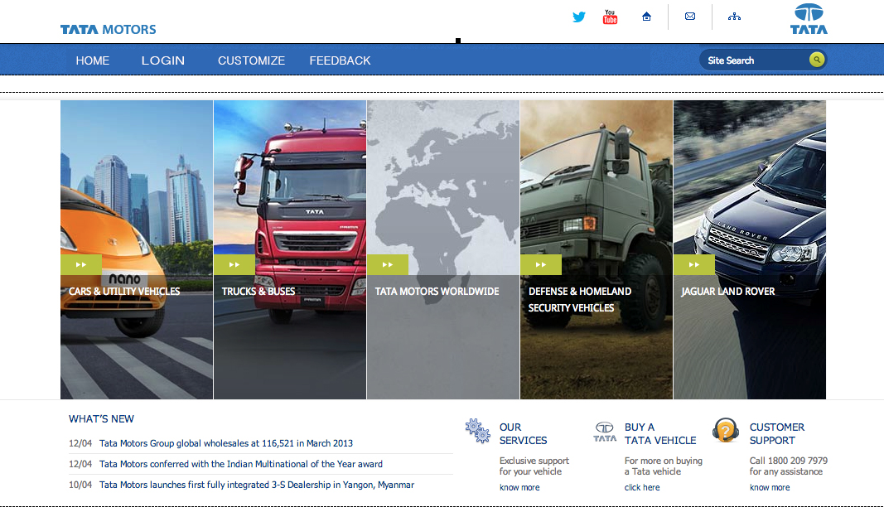

Diagram 2. Home Page

Once the user is logged in to the system they will be able to select which Tata Motors car model they would like to customize and eventually purchase by just clicking on the one they want.

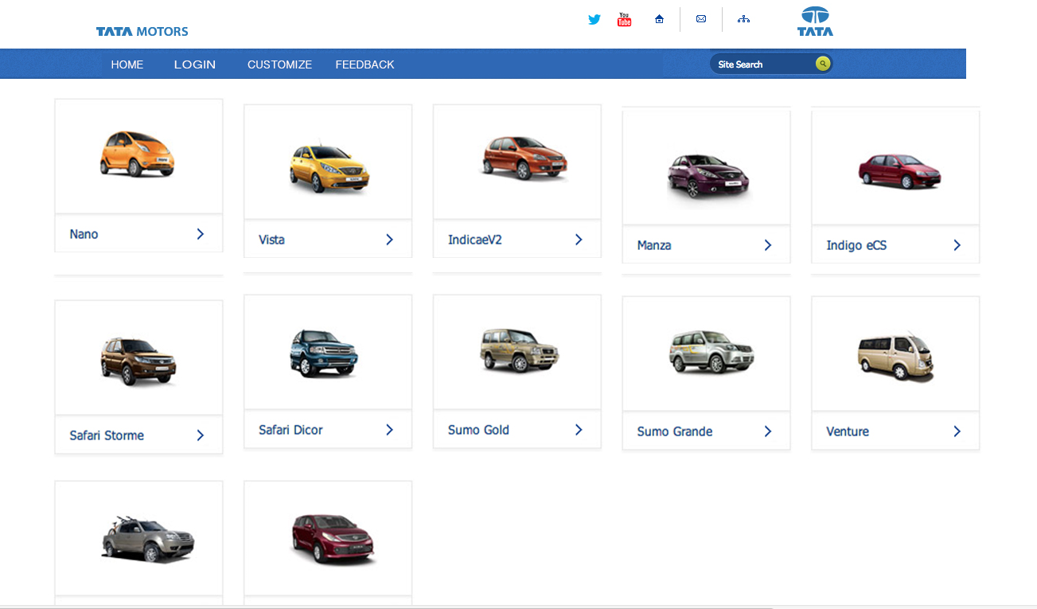

Diagram 3. Car Model selection Page

Once the user has chosen their car model they will be able to customize their vehicle by clicking on checkbox choices or by just clicking on the color they would like.

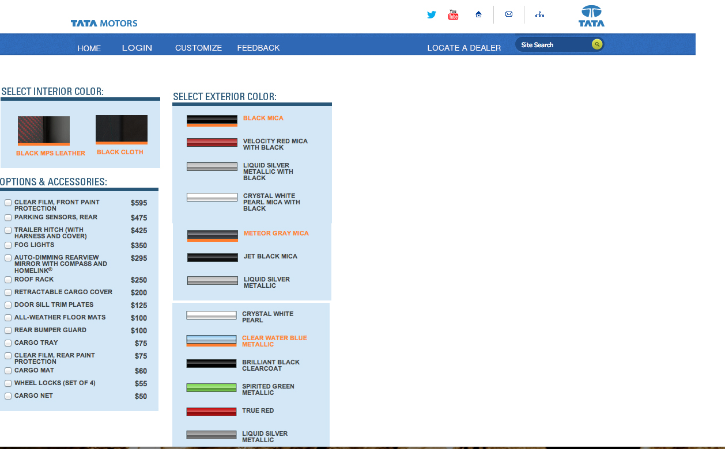

Diagram 4. Customization Page

